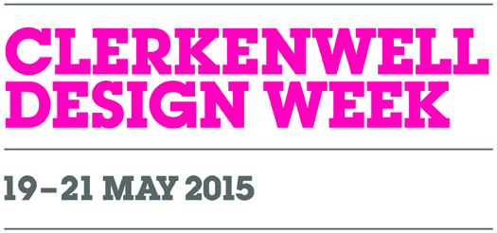
Zig-Zag – everything handy.
Everything within arm’s reach. A laptop, a remote, a telephone, a book and a coffee. Everything
on the Zig-Zag coffee tables design by German duo WertelOberfell. They are light, different sizes and heights. You can have one or more, because they great fits in each other. We play with a colour
and shape of counters. Heights are adapted to the seat. The Zig-Zag coffee tables may create mono or multi-touch colour accent in the interior.
Plywood counters of regular, round and gently curved shapes occur in nine explicit colours and four sizes. Its metal, black base has four heights. Iker’s stylists suggests to combine them together
to create furniture compositions.

WertelOberfell
The WertelOberfell studio, www.platform-net.com, was established in 2007 by Gernot Oberfell (1975) and Jan Wertel (1976). Both of them studied Industrial Design at the Stuttgart State Academy of Art and Design, a school based on the principles of the Ulmer Schule and Bauhaus. The studio has been located in London and Munich. At the time, they both worked for the Ross Lovegrove Studio for several years.The scope of their design work is very broad. They have worked for brands such as Sony, Yamagiwa, MGX by Materialise, Iker, BN Office Solution, DuPont Corian and others. Some of their works have been exhibited in museums across the world and they are part of permanent collections of the Metropolitan Museum of Art in New York and the Victoria & Albert Museum in London.Jan and Gernot’s work is a combination of logic and the perfection of organic forms. They make optimum use of the qualities of materials, production processes, but first of all, ergonomics.
Iker.com.pl Ikershop.com Onandondesigns.com

